Contents
INTRODUCTION 2
PROBLEM DESCRIPTION AND BACKGROUND 4
BACKGROUND OF THE PROBLEM 5
COMMUNITY IMPACT 6
PROPOSED SOLUTION 7
COMPUTATIONAL THINKING PROCESS 8
ALGORITHM DESIGN 9
PSEUDOCODE 10
FLOWCHART 13
LOGICAL DESIGN 16
FUNCTIONAL MODULES AND FUNCTIONS 17
EXPECTED OUTPUTS AND SAMPLE SCENARIOS 19
SUSTAINABLE DEVELOPMENT GOALS 22
OPEN SOURCE SOFTWARE JUSTIFICATION 23
DIGITAL PUBLIC GOODS JUSTIFICATION 24
SIERRA LEONE COMMUNITY IMPACT AND LONG-TERM SUSTAINABILITY 25
LIMITATIONS AND RECOMMENDATIONS 27
GITHUB AND VERSION CONTROL 28
CONCLUSION 29
REFERENCES 30

INTRODUCTION
Waste management is an important part of maintaining clean, healthy, and sustainable communities. The proper collection and disposal of household and commercial waste can improve public cleanliness, protect the environment, and support the well-being of residents.
In Sierra Leone, communities may experience challenges such as uncollected rubbish, overflowing waste containers, illegal dumping, poor coordination of collection services, and delays in reporting waste-related problems. These challenges can affect residents, businesses, public spaces, and the environment.
This project proposes a Smart Waste Collection and Management System (SWCMS) to improve the reporting, recording, prioritisation, and tracking of waste collection requests.
The proposed system is a logical design rather than a fully programmed application. It demonstrates how computational thinking, algorithms, pseudocode, flowcharts, decision structures, repetition structures, modules, and functions can be used to address a real community problem.
The system is intended for residents, waste collection workers, community representatives, and local authorities. It will provide a structured way to submit waste reports, validate information, assign collection priorities, update request statuses, and produce simple management reports.
  - Aim of the Project
The main aim of this project is to design a logical and accessible waste management system that improves the coordination of waste collection and reporting in Sierra Leonean communities.
  - Objectives
The specific objectives are to:
- Identify common waste management challenges affecting local communities.
- Design an algorithm for recording and processing waste collection requests.
- Develop pseudocode and a flowchart showing the system's logical operations.
- Apply input validation, decision structures, repetition structures, modules, and functions.
- Demonstrate expected outputs using sample scenarios.
- Explain how the proposed solution supports relevant Sustainable Development Goals.
- Explain how open-source software and digital public goods principles can support the project.
- Propose a sustainable approach to improving community waste management.
  - Scope of the Project
The proposed system will focus on:
- Recording waste collection requests.
- Collecting basic information about the location and type of waste.
- Validating submitted information.
- Assigning priority levels to reports.
- Recording collection assignments.
- Updating the status of requests.
- Generating simple summaries for waste management personnel.
The initial design will not include automatic vehicle tracking, online payments, artificial intelligence, or direct integration with government databases.

PROBLEM DESCRIPTION AND BACKGROUND
  - Statement of the Problem
Waste collection in some communities can be affected by delayed reporting, incomplete location information, poor communication between residents and collection teams, and difficulties tracking unresolved complaints.
When residents cannot easily report uncollected waste, responsible organisations may have difficulty identifying which areas need attention. Reports may also be duplicated, forgotten, or left unresolved without clear status updates.
These problems can contribute to environmental pollution, unpleasant surroundings, blocked drainage, and reduced community cleanliness.
The proposed Smart Waste Collection and Management System aims to address these difficulties by providing a structured process for recording reports, assigning priorities, tracking collection requests, and monitoring outstanding work.
  - Who Is Affected?
The main groups affected include:
- Residents: People who need clean and safe surroundings.
- Waste collection workers: Teams responsible for collecting and transporting waste.
- Local authorities: Organisations responsible for coordinating or overseeing waste management.
- Business owners: Shops, markets, restaurants, and other businesses that generate waste.
- Schools and public institutions: Places that require hygienic surroundings.
- The environment: Land, waterways, drainage systems, and public spaces affected by improper waste disposal.
  - Why the Problem Exists
Potential contributing factors include:
- Limited communication channels for reporting waste problems.
- Incomplete or inaccurate location descriptions.
- Delays in responding to collection requests.
- Insufficient coordination between residents and collection teams.
- Limited records of completed and outstanding requests.
- Inadequate public awareness of proper waste disposal.
- Limited resources, including vehicles, workers, and collection containers.
These are possible causes that should be confirmed through local observation or interviews before the system is implemented.

BACKGROUND OF THE PROBLEM
Waste management requires cooperation between residents, collection workers, local authorities, and other stakeholders. An effective process needs accurate information about where waste is located, what type of waste requires attention, and whether a collection request has been completed.
Traditional reporting methods, including verbal complaints and informal messages, can make it difficult to maintain consistent records. A simple digital reporting process could help organise this information and improve communication.
The proposed system would allow a resident or community representative to submit a report containing a location, waste category, description, and urgency level. The system would validate the information and store the report for review.
A responsible officer could then assign the request to a collection team, update its status, and record whether the collection was completed.
The system would not replace physical collection services. Instead, it would improve the organisation and monitoring of those services.

COMMUNITY IMPACT
The system could give residents a clear way to report waste problems, help collection teams receive organised information, and allow officers to monitor outstanding tasks. Records may also help identify recurring problem areas and improve future planning.
  - Beneficiaries
Primary beneficiaries include residents, local authorities, collection workers, market communities, schools, and businesses. Visitors and future generations may also benefit from cleaner surroundings.
  - Expected Long-Term Impact
If the system is supported by reliable physical collection services, adequate resources, public participation, and regular maintenance, it could improve the consistency of reporting and collection planning. These are expected benefits, not proven results; a pilot would be needed to measure actual impact.

PROPOSED SOLUTION
The SWCMS is a proposed digital process for recording and managing waste collection requests. A resident or community representative submits a report with a community, location, waste category, description, and urgency information. The system validates the information, creates a reference number, assigns a priority, and stores the report as Pending. An authorised officer can then assign a collection team and monitor progress.
  - Main Users
Resident/reporter: submits a report and receives a reference number.
Waste management officer: reviews reports, assigns teams, and monitors progress.
Collection worker: views assigned tasks and updates statuses.
Administrator: manages authorised users, categories, and system settings.
  - Data Fields
Report reference number and submission date.
Community and specific location or landmark.
Waste category and problem description.
Urgency and priority level.
Current status and assigned team, where applicable.
Completion date and outcome, when resolved.
The system should avoid collecting unnecessary personal information. Contact details should only be requested when needed for follow-up.
  - Report Statuses
Pending — recorded but not yet assigned.
Assigned — a collection team has been selected.
In Progress — the team is working on the task.
Resolved — collection has been completed and recorded.
Rejected — the report was reviewed and found invalid or outside the service’s scope.
A rejected report should include a reason, and a resolved report should contain a completion record.

COMPUTATIONAL THINKING PROCESS
  - Decomposition
The problem is divided into smaller tasks: report submission, input validation, report identification, priority classification, task assignment, status tracking, and output generation. Each task can be designed and tested separately.
  - Pattern Recognition
The system may reveal recurring reports from the same area, frequent waste categories, requests that remain pending for long periods, or collection demand that rises on certain days. These patterns could help officers plan resources.
  - Abstraction
The system records only information needed to coordinate collection: location, category, description, urgency, status, and assignment. It avoids unnecessary personal details and unrelated information.
  - Algorithmic Thinking
The system follows a defined sequence: receive details, validate fields, create a reference number, determine priority, save the report, show confirmation, assign work, update status, and generate summaries.

ALGORITHM DESIGN
  - Algorithm: Submit a Waste Report
- Start.
- Display the report form.
- Receive community, location, category, description, and urgency information.
- Check that all required fields are complete.
- If information is missing, request correction.
- Validate the location and waste category.
- If invalid, display an error and request correction.
- Generate a unique report reference number.
- Determine priority using defined rules.
- Save the report with Pending status.
- Display the reference number and confirmation.
- Stop.
  - Priority Classification
- Receive a valid report.
- Check whether it describes an immediate public-safety concern; if yes, classify it High for prompt review.
- Otherwise, check whether it describes overflowing waste or waste affecting drainage; if yes, classify it Medium.
- Otherwise, classify it Normal.
- Save and return the priority.
Priority rules are proposed administrative guidance, not a substitute for professional assessment. An authorised officer should be able to review and adjust priority.
  - Task Assignment
- Retrieve reports with Pending status.
- Display them to an authorised officer.
- Select a report and display available collection teams.
- Select a suitable team.
- If the team is valid and available, save the assignment and set status to Assigned.
- Otherwise, display an error and request another selection.
- Repeat until the officer exits or no reports remain.
  - Status Update
- Receive the report reference number.
- Search for the report; if it does not exist, display an error.
- Display the current status and request a new status.
- Check whether the status transition is permitted.
- If invalid, display an error; otherwise save the status.
- If Resolved, record the completion date and outcome.
- Display confirmation and stop.

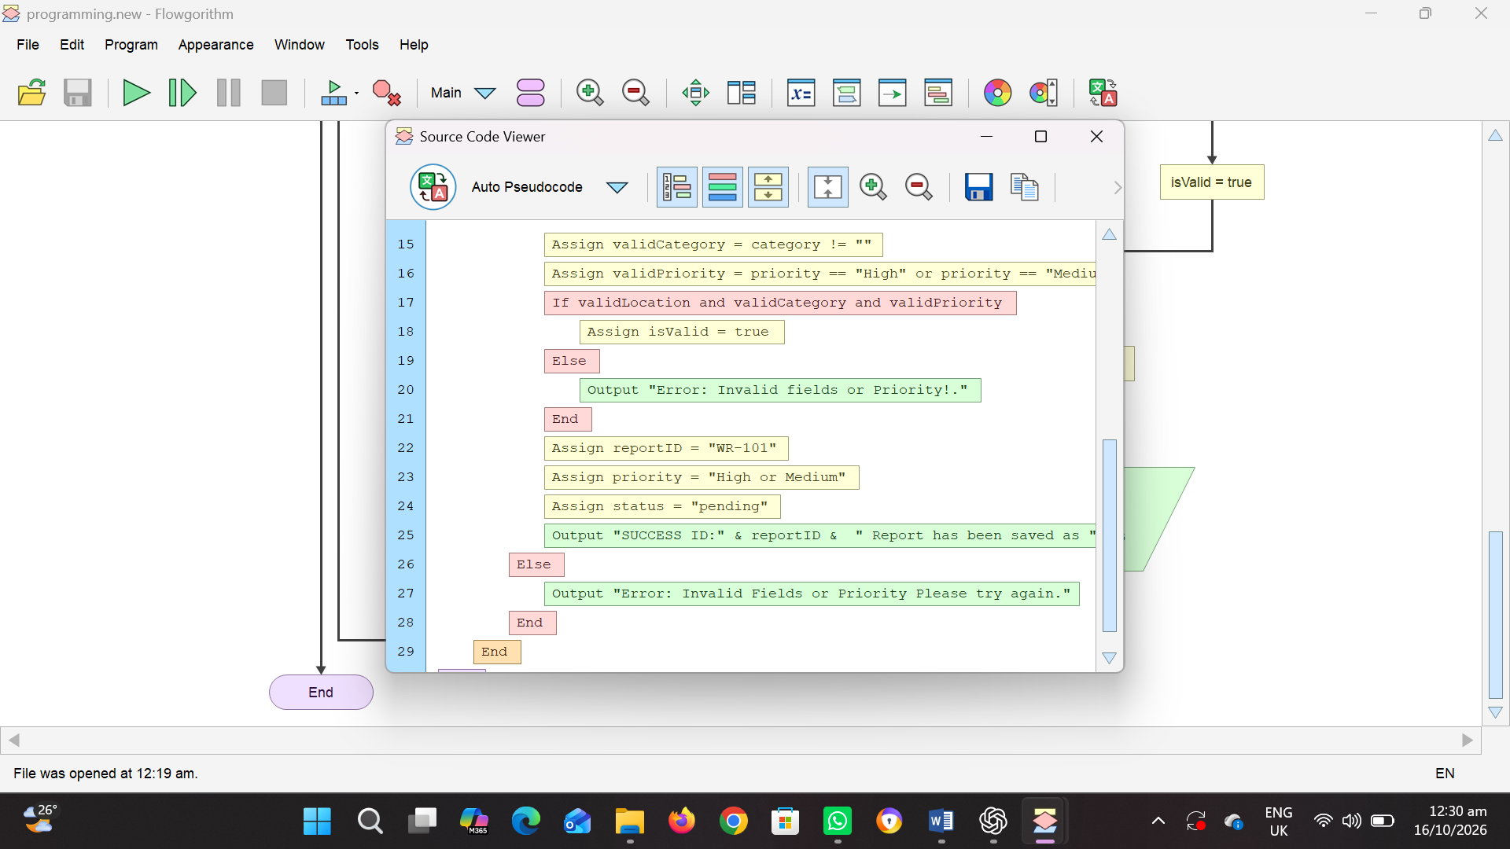
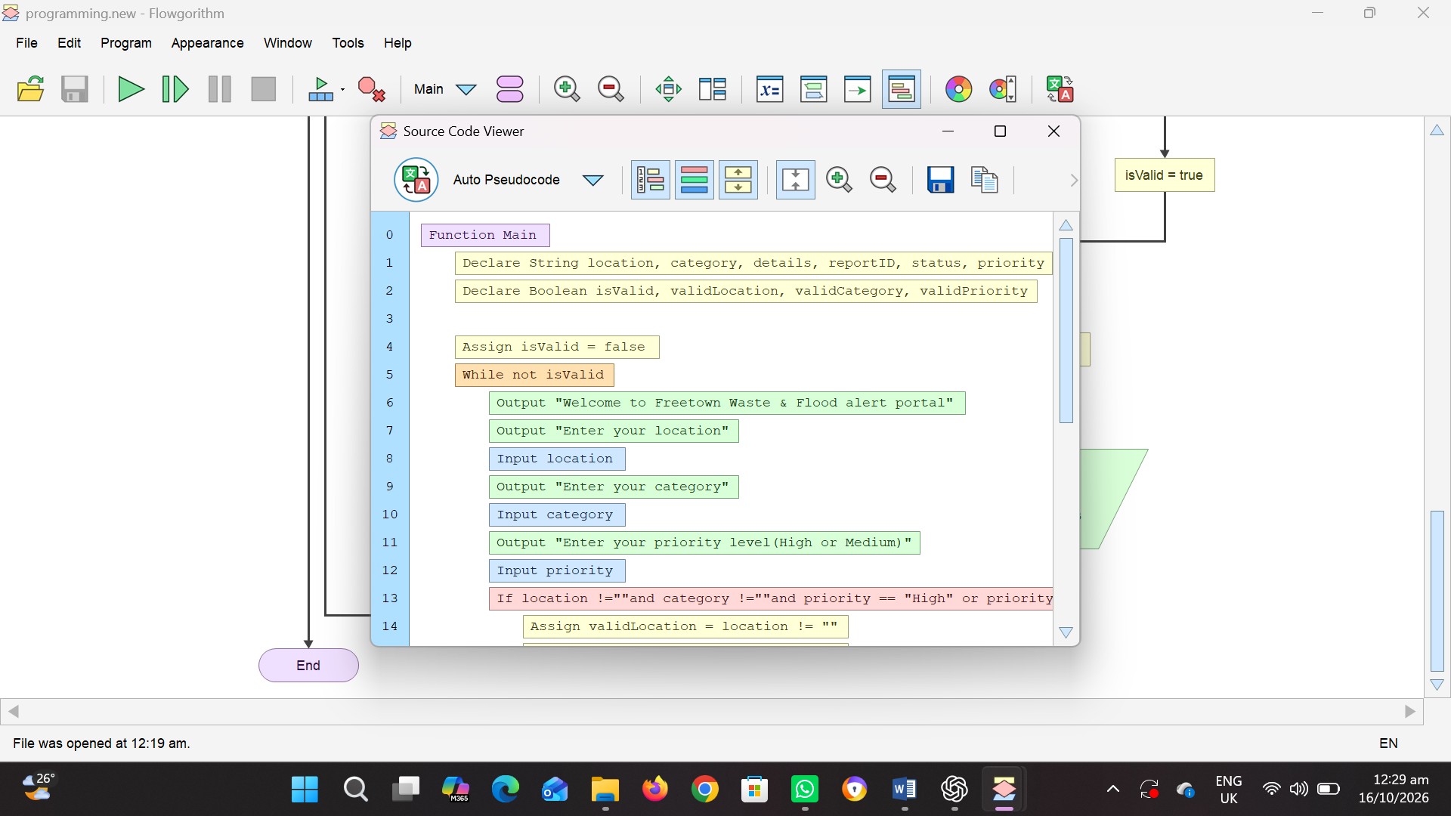
PSEUDOCODE

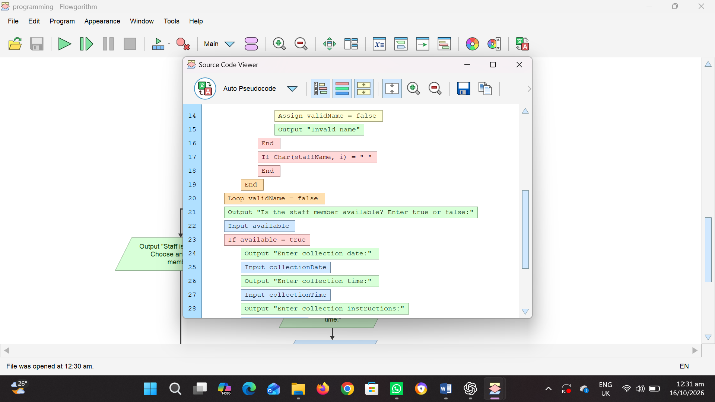
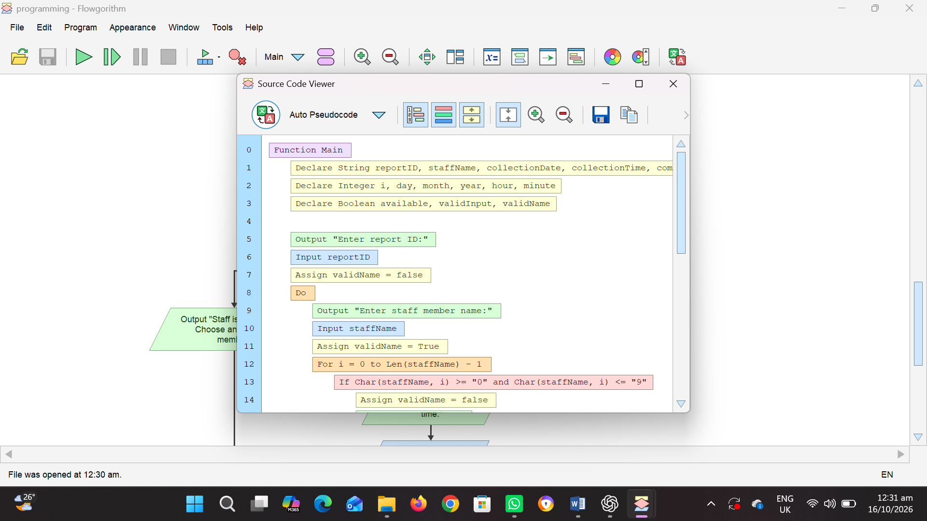

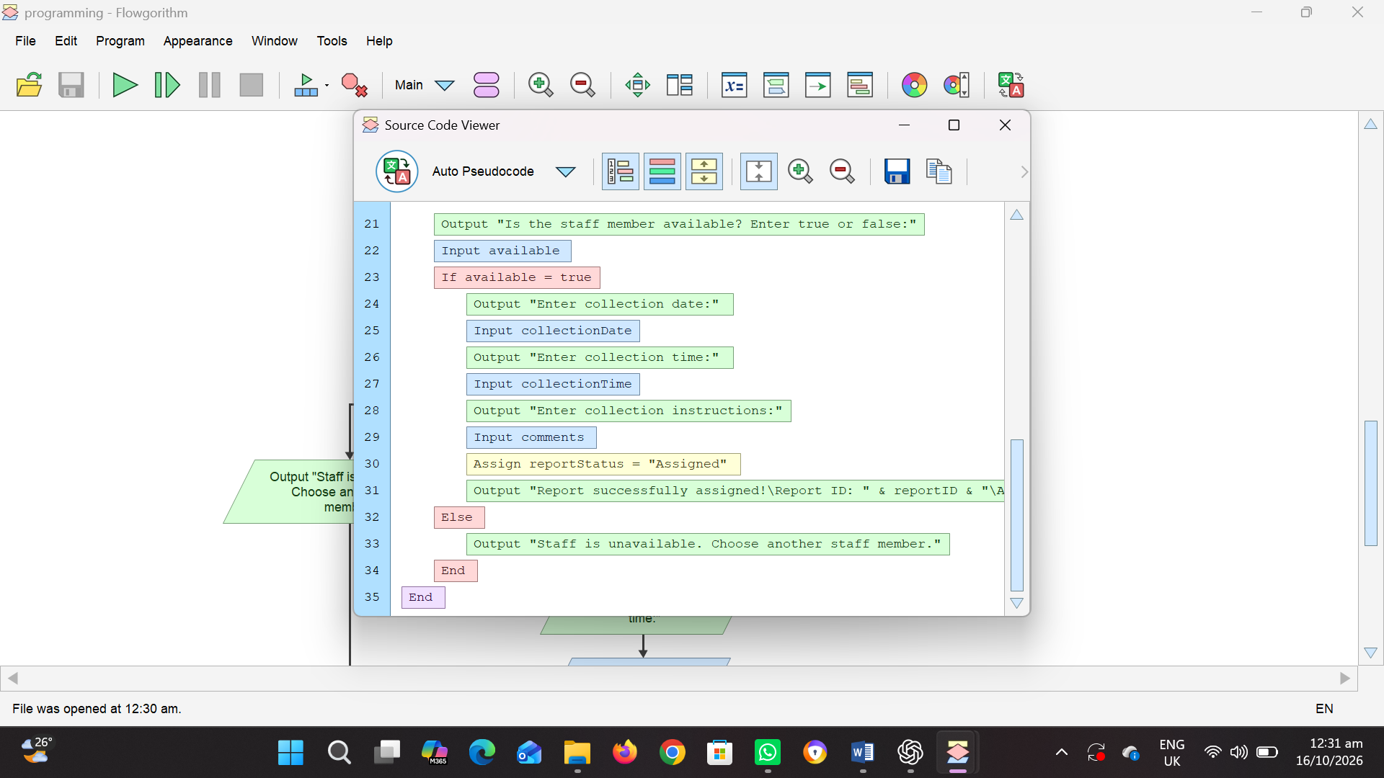

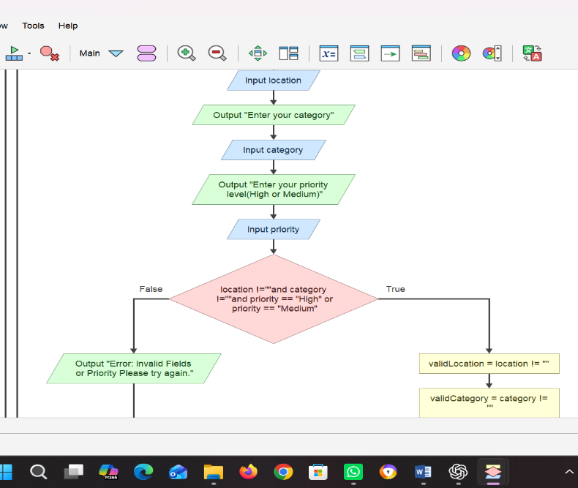
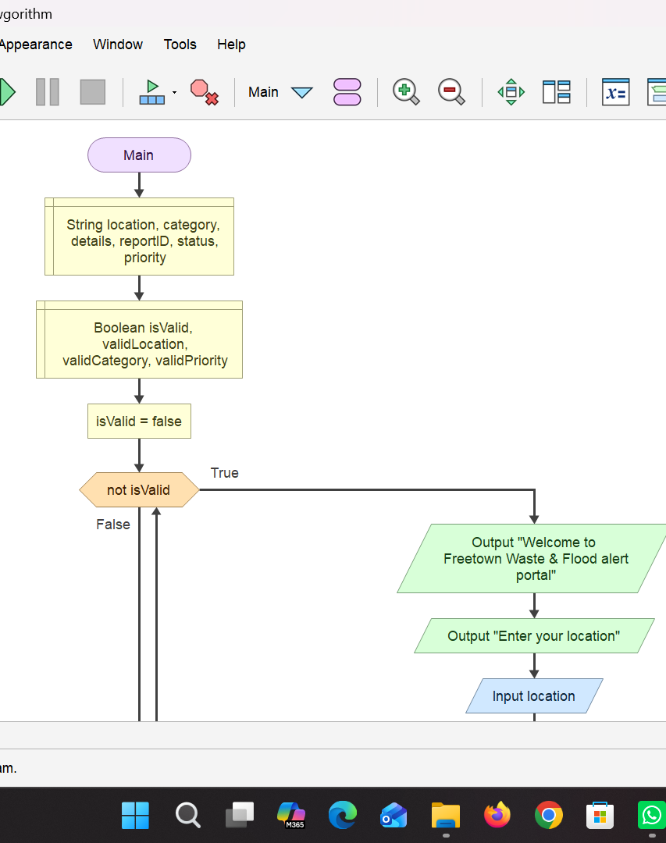
FLOWCHART
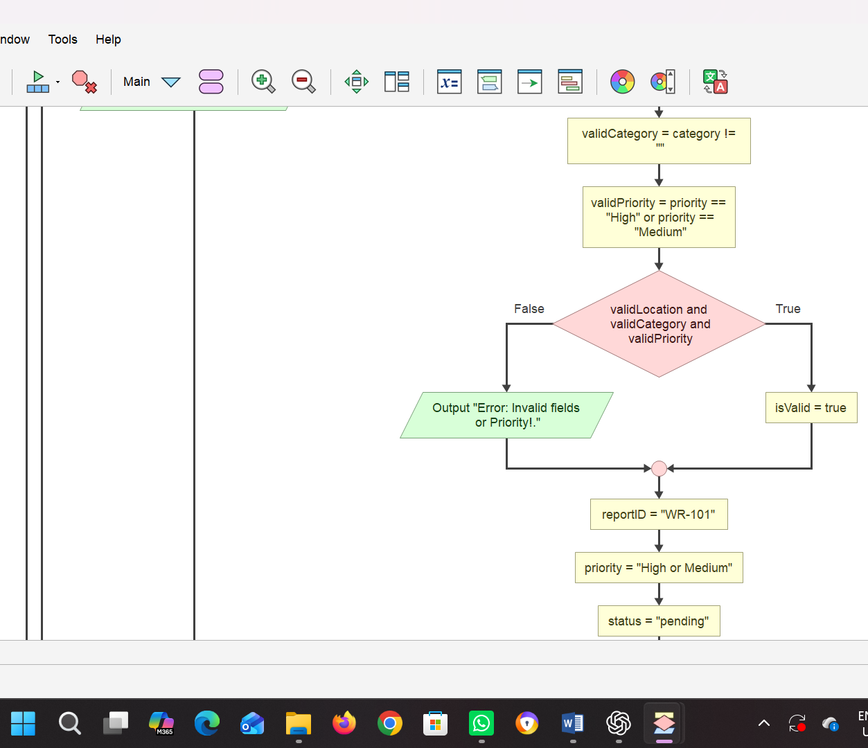
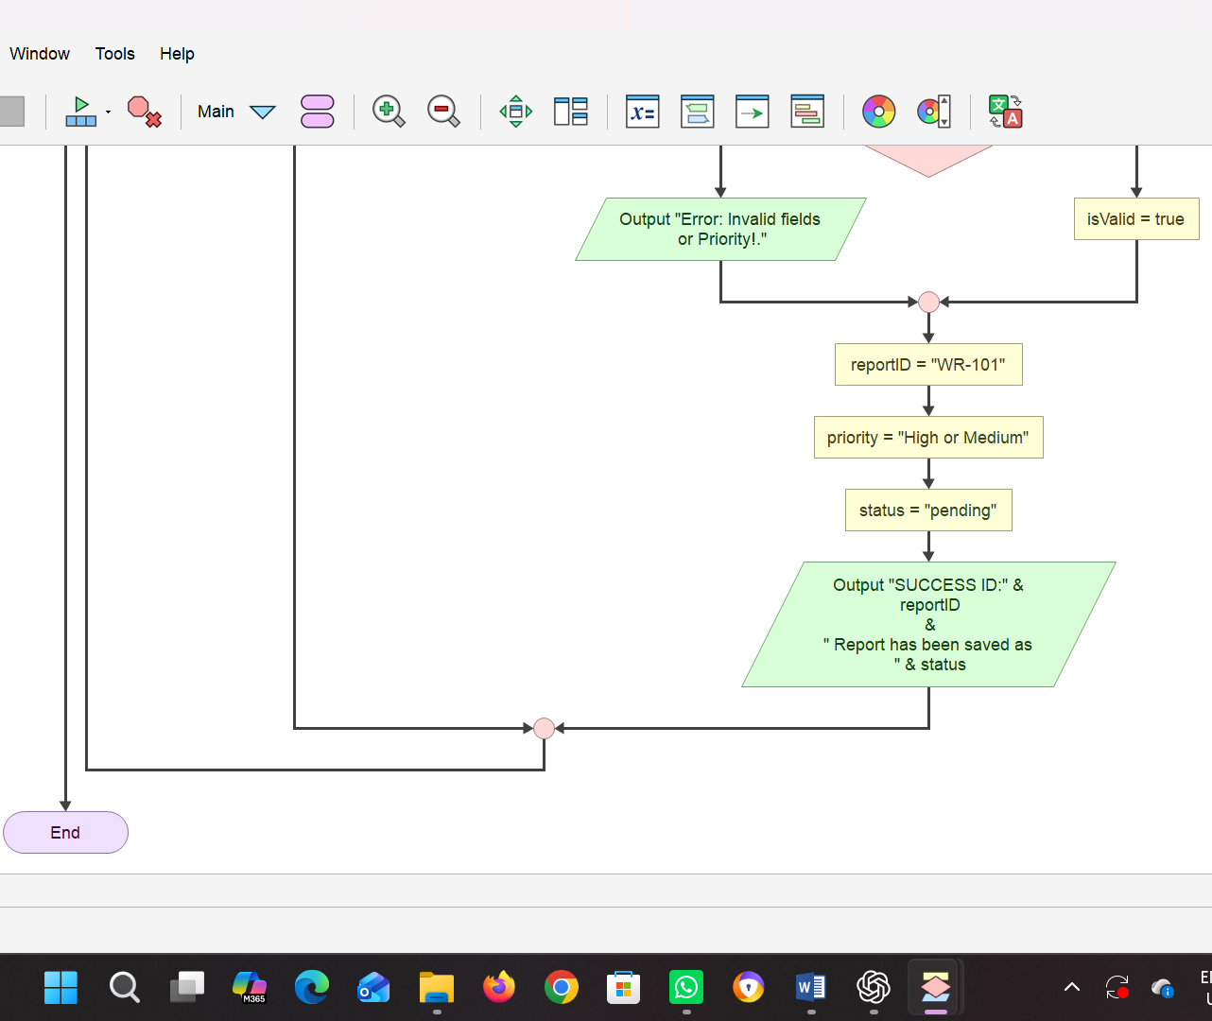
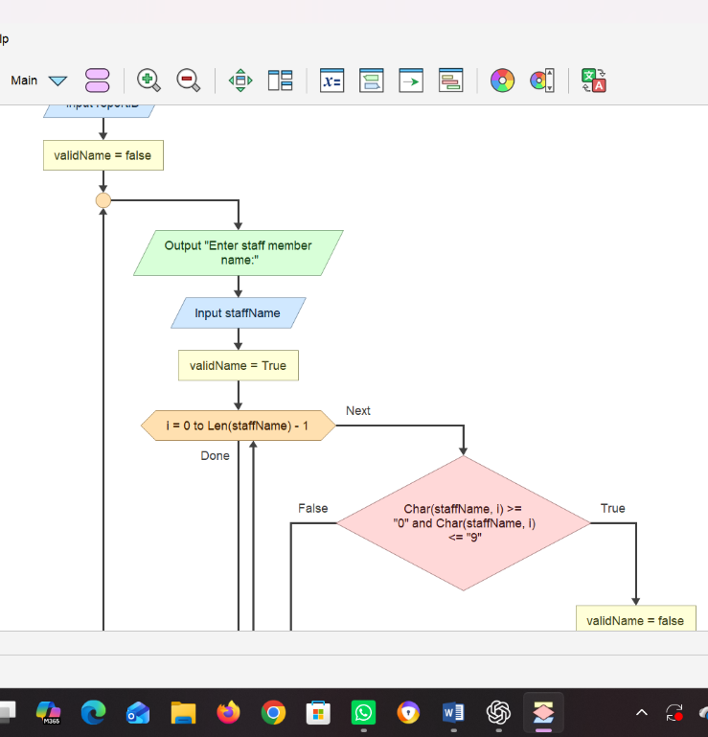
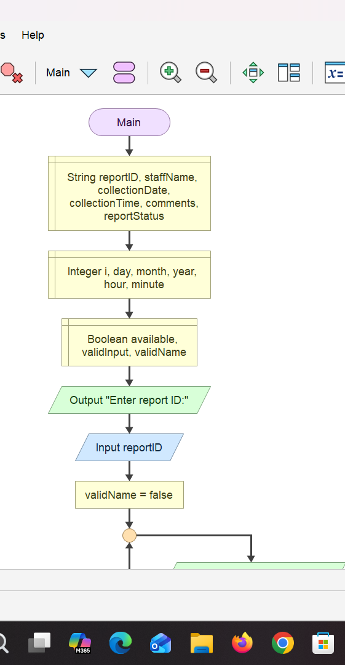

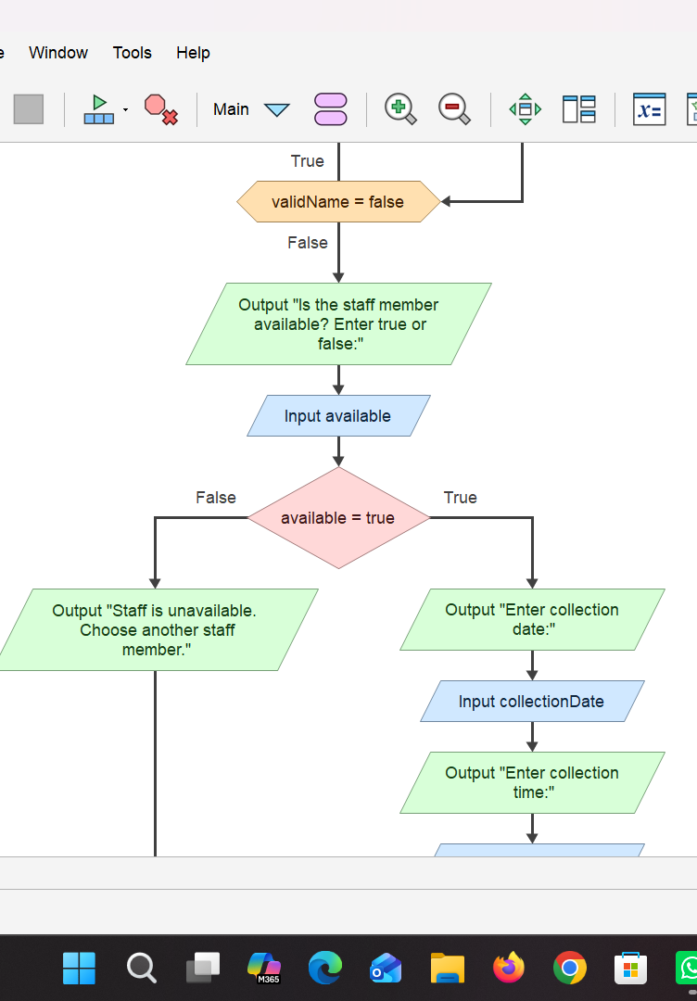
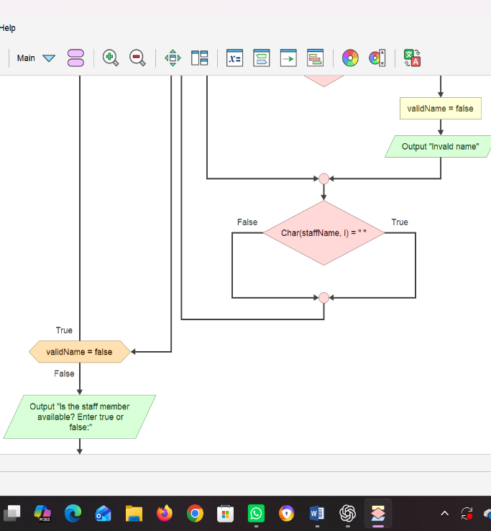

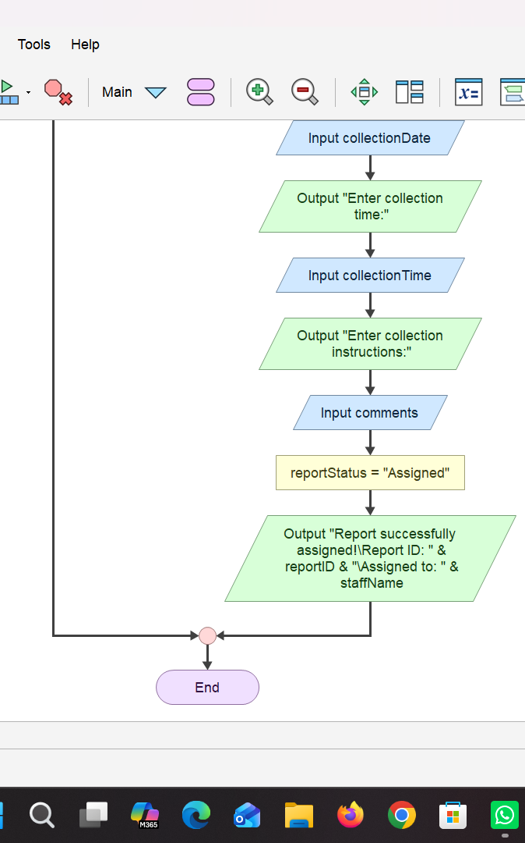

LOGICAL DESIGN
Input
Menu selection.
Community, location, waste category, description, and urgency information.
Report reference number, team identifier, and requested status update.
Processing
Validate required fields and identifiers.
Generate unique report references.
Classify priority.
Store and retrieve reports.
Assign tasks and validate status transitions.
Count reports and generate summaries.
Output
Submission confirmation and reference number.
Priority and current status.
Assignment confirmation.
Validation and error messages.
Summary of pending, assigned, in-progress, resolved, and rejected reports.
Decision Structures
IF–ELSE decisions check required fields, location and category validity, priority, report existence, team availability, menu choices, and permitted status transitions.
Repetition Structures
The menu repeats until Exit is selected. Validation repeats while required information is missing. Summary reporting loops through report records. Assignment can repeat for multiple reports in one session.
Modular Design and Functions
The design separates submission, priority classification, assignment, status management, and summary reporting into modules. Example functions include GenerateReportID(), ClassifyPriority(), ValidateReport(), ValidateStatusTransition(), and CountReportsByStatus().

FUNCTIONAL MODULES AND FUNCTIONS
  - Report Submission Module
Purpose: Receives and validates new waste reports.
Inputs: Community, location, category, description, and urgency information.
Process: Checks required fields, validates the data, generates a reference number, and saves the report.
Output: Report confirmation, reference number, priority, and Pending status.
  - Priority Classification Module
Purpose: Helps officers organise reports by urgency.
Inputs: Report category, description, and urgency information.
Process: Applies the defined priority rules.
Output: High, Medium, or Normal priority.
  - Collection Assignment Module
Purpose: Assigns a pending report to an available collection team.
Inputs: Report reference number and team identifier.
Process: Verifies the report and team before saving the assignment.
Output: Assignment confirmation and Assigned status.
  - Status Management Module
Purpose: Records progress on an assigned collection request.
Inputs: Report reference number and proposed status.
Process: Checks the existing report and validates the requested status transition.
Output: Updated status or an error message.
  - Summary Reporting Module
Purpose: Provides an overview of collection work.
Inputs: Stored report records.
Process: Counts reports by status and may group reports by community or category.
Output: A summary of outstanding and completed work.
  - Module Integration
The main program coordinates the modules through a menu. Each module performs its assigned operation and returns control to the main menu when finished.
The modules share the report records, while access permissions determine which users can create, assign, update, or review information.

EXPECTED OUTPUTS AND SAMPLE SCENARIOS
The following are hypothetical examples used to demonstrate the proposed logic. They are not real reports collected from Sierra Leonean communities.
  - Scenario 1: Successful Report Submission
Input
- Community: Example Community A
- Location: Near the community market
- Category: Household waste
- Description: Waste has not been collected.
- Urgency information: Normal
Expected output
SMART WASTE MANAGEMENT SYSTEM

Report submitted successfully.
Reference Number: SW-0001
Priority: Normal
Status: Pending

Please keep your reference number.
  - Scenario 2: Incomplete Information
Input
- Community: Example Community B
- Location: [Blank]
- Category: Household waste
- Description: Waste is overflowing.
Expected output
ERROR: Required information is missing.

Please provide the location
before submitting the report.
The system requests correction before saving the report.
  - Scenario 3: Urgent Report
Input
- Community: Example Community C
- Location: Near a public drainage channel
- Category: Mixed waste
- Description: Overflowing waste is obstructing drainage.
- Urgency information: Drainage obstruction
Expected output
Report submitted successfully.
Reference Number: SW-0002
Priority: Medium
Status: Pending
The responsible officer reviews the report and determines the appropriate response. If an immediate safety concern is identified, the officer can escalate its priority.
  - Scenario 4: Successful Collection Assignment
Input
- Report reference: SW-0001
- Selected team: TEAM-01
- Team availability: Available
- Current report status: Pending
Expected output
Collection task assigned successfully.
Report Reference: SW-0001
Assigned Team: TEAM-01
New Status: Assigned
  - Scenario 5: Report Not Found
Input
- Report reference: SW-9999
Expected output
ERROR: Report not found.
Please check the reference number.
No report is updated.
  - Scenario 6: Summary Report
Assume the system contains ten hypothetical reports with these statuses.
Status | Number of reports
Pending | 3
Assigned | 2
In Progress | 1
Resolved | 3
Rejected | 1
Total | 10
Expected output
WASTE COLLECTION SUMMARY

Total Reports: 10
Pending: 3
Assigned: 2
In Progress: 1
Resolved: 3
Rejected: 1
The counts add up to ten, demonstrating that the summary module can account for the example records.

SUSTAINABLE DEVELOPMENT GOALS
Sustainable Cities and Communities
SDG 11 aims to make cities and human settlements inclusive, safe, resilient, and sustainable. Target 11.6 addresses reducing the environmental impact of cities, including attention to municipal and other waste management. The proposed system supports this goal by helping residents report waste problems, organising requests by location and priority, monitoring collection work, and producing records that can assist local planning.
  - Responsible Consumption and Production
SDG 12 promotes sustainable consumption and production. The system could record waste categories and help identify opportunities for better collection, sorting, recycling, and waste reduction where local services support them. The software alone cannot guarantee recycling; suitable facilities, awareness, and cooperation are also required.

OPEN SOURCE SOFTWARE JUSTIFICATION
  - Meaning of Open Source Software
Open-source software is software whose source code is made available under a licence that permits people to use, study, modify, and redistribute it according to the licence terms.
  - Why the Proposed Solution Should Be Open Source
The proposed system should use an open-source approach because it could allow local developers, students, community organisations, and public institutions to inspect and improve the design.
An open approach can support:
- Transparency: Contributors can examine how the system's logic works.
- Cost efficiency: Organisations can adapt existing work rather than depending entirely on a proprietary solution.
- Local adaptation: Developers can adjust report categories and collection procedures to local requirements.
- Collaboration: Students and developers can suggest improvements and correct errors.
- Knowledge sharing: Other communities can learn from the design.
- Long-term flexibility: Organisations are less dependent on a single software supplier.
Open-source software may still require funding for hosting, maintenance, staff training, and physical waste collection services.
  - Benefits for Sierra Leone
An open-source design could help local technology students gain practical experience, encourage local software development, and make it easier for organisations to adapt the system to their operational needs.
For example, a community organisation could customise the reporting form to reflect its local neighbourhoods and collection arrangements.
  - Potential Community Contributions
Potential contributors include:
- Students who improve the pseudocode and documentation.
- Developers who implement the logical design.
- Community representatives who suggest useful reporting categories.
- Waste collection organisations that review operational requirements.
- Translators who help make the interface understandable to more residents.
- Testers who identify errors and accessibility problems.
Contributions should be reviewed before being included in a live system.

DIGITAL PUBLIC GOODS JUSTIFICATION
  - Meaning of Digital Public Goods
Digital public goods can include open-source software, open data, open AI systems, open standards, and open content that follow relevant legal, privacy, and safety practices and contribute to the Sustainable Development Goals. [3]
  - How the Proposed System Could Become a Digital Public Good
The Smart Waste Collection and Management System could be developed with the intention of serving the public interest.
To move towards becoming a digital public good, it should:
- Be released under an appropriate open-source licence.
- Provide clear documentation for installation, use, and modification.
- Use open and accessible standards where practical.
- Protect personal and sensitive information.
- Avoid publishing residents' private contact details or other identifying data.
- Support the Sustainable Development Goals.
- Be designed so other communities can adapt it.
- Follow applicable laws and responsible data practices.
- Provide a clear process for community contributions and maintenance.
  - Accessibility, Openness, and Public Benefit
The proposed system should use simple language, clear instructions, and an accessible interface. If implemented, it could also offer low-bandwidth access and a process through which authorised staff can enter reports submitted offline or in person.
Where feasible, basic public information—such as anonymised counts of pending and completed collection requests—could be shared to improve accountability.
Sensitive information should remain restricted to authorised users.
  - Important Limitation
Publishing a project on GitHub does not automatically make it a recognised digital public good. Recognition requires the relevant Digital Public Goods Standard and review process to be satisfied. [3]
At the current assignment stage, this project is a proposed design that could be developed towards the digital public goods principles; it is not a certified digital public good.

SIERRA LEONE COMMUNITY IMPACT AND LONG-TERM SUSTAINABILITY
  - The Problem Being Addressed
The project addresses difficulties in reporting, organising, assigning, and monitoring waste collection requests.
  - Expected Local Impact
If adopted and properly maintained, the system could:
- Improve the visibility of uncollected waste.
- Help responsible officers organise collection requests.
- Support better communication with residents.
- Make outstanding tasks easier to monitor.
- Help identify recurring waste management problems.
- Encourage community participation and environmental responsibility.
These are expected benefits rather than proven results. Actual impact would need to be measured during a pilot.
  - Beneficiaries
Residents, local authorities, waste collection workers, market communities, schools, businesses, and the wider environment could benefit from improved waste collection coordination.
  - Long-Term Sustainability
Long-term sustainability would require the following measures:
Community participation: Residents should be encouraged to report problems accurately and follow proper waste disposal practices.
Institutional ownership: A responsible organisation should oversee the system, its data, and its daily operations.
Maintenance: The system should receive regular updates, backups, security checks, and corrections.
Training: Officers and collection workers should receive practical training before using the system.
Financial planning: A budget should cover hosting, equipment, connectivity, maintenance, and staff training where required.
Privacy and security: Access permissions and appropriate safeguards should protect personal information.
Performance monitoring: The organisation should monitor response times, completion rates, unresolved reports, and recurring problem areas.
Offline inclusion: Residents without reliable internet access should still be able to report problems through an assisted reporting channel.
  - Measures of Success
A future pilot could measure:
- Number of reports received.
- Percentage of reports containing valid location information.
- Percentage of reports assigned to a collection team.
- Average time between reporting and assignment.
- Percentage of assigned reports marked as resolved.
- Number of repeated reports from the same location.
- Feedback from residents and collection workers.
Baseline figures should be collected before implementation so that later results can be compared fairly.

LIMITATIONS AND RECOMMENDATIONS
  - Limitations
- This is a logical design, not a working application.
- The system depends on accurate information from reporters.
- Some residents may have limited digital access.
- Physical collection still requires workers, vehicles, and equipment.
- False or duplicate reports may need manual review.
- Priority rules may need adjustment to local conditions.
- The design has not been tested using actual community data.
  - Recommendations
- Interview residents and waste collection personnel.
- Pilot the system in one community before wider adoption.
- Provide a simple reporting interface and assisted reporting option.
- Set clear rules for assigning and resolving requests.
- Train users and responsible officers.
- Protect personal information and restrict administrative access.
- Maintain backups and document changes.
- Evaluate performance using real, appropriately protected data.

GITHUB AND VERSION CONTROL
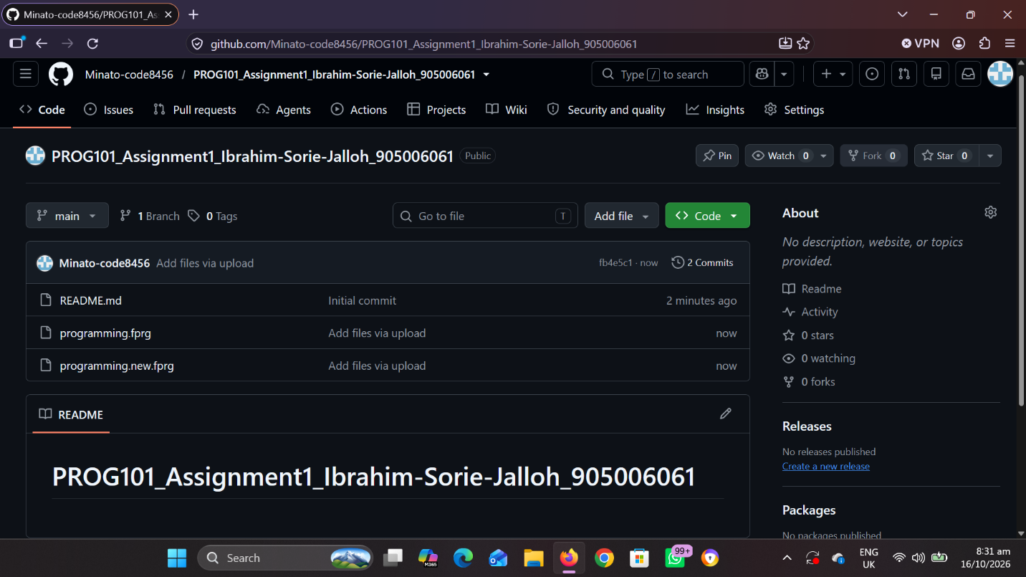
Git is a version control system used to record changes to files over time. GitHub is an online platform that hosts Git repositories and supports collaboration.

https://github.com/Minato-code8456/PROG101_Assignment1_Ibrahim-Sorie-Jalloh_905006061.git

CONCLUSION
The Smart Waste Collection and Management System is a proposed logical solution to challenges associated with reporting and coordinating waste collection in Sierra Leone.
The project demonstrates how computational thinking can break a community problem into smaller tasks and how algorithms, pseudocode, flowcharts, decision structures, repetition structures, modules, and functions can be used to design a solution.
The proposed system would help organise reports, validate submitted information, classify priorities, assign collection teams, monitor statuses, and generate summary reports.
The project also supports relevant Sustainable Development Goals, particularly SDG 11 and SDG 12, while demonstrating how open-source software and digital public goods principles could promote accessibility, collaboration, transparency, and public benefit.
Although the system cannot replace physical waste collection services, it could improve coordination and accountability if implemented with adequate resources, community participation, privacy safeguards, and long-term maintenance.
In conclusion, the project demonstrates how a carefully designed logical system can contribute to addressing a practical community challenge while applying the fundamental principles of programming logic and design.

REFERENCES
United Nations Department of Economic and Social Affairs. (n.d.). Goal 11: Sustainable Cities and Communities. https://sdgs.un.org/goals/goal11
United Nations. (n.d.). Sustainable Development Goals: Goal 12—Responsible Consumption and Production. https://www.un.org/sustainabledevelopment/sustainable-consumption-production/
Digital Public Goods Alliance(n.d.). Digital Public Goods Standard. https://digitalpublicgoods.net/standard/
GitHub. (n.d.). GitHub Documentation. https://docs.github.com/
diagrams.net. (n.d.). diagrams.net. https://www.diagrams.net

